Module End Assignment MySQL
E-Commerce Customer Churn Analysis
Documentation
[Prithviraj K]
Introduction
In the highly competitive realm of e-commerce, understanding and preventing customer churn is essential for ensuring customer satisfaction and maintaining sustained profitability.
This project delves into the dynamics of customer attrition within an e-commerce domain. By leveraging historical transactional data, the analysis aims to uncover the underlying patterns and primary drivers of churn. We will investigate key customer attributes, including:
- Customer Tenure
- Preferred Payment Modes
- Satisfaction Scores
- Purchase Behaviour
Objective
The ultimate goal of this project is to equip e-commerce enterprises with actionable, data-driven insights. By understanding a customer's propensity to churn, businesses can proactively implement targeted retention strategies, mitigate attrition, and foster long-term customer relationships, ensuring long-term viability in a competitive landscape.

Project Steps and Objectives:
Data Cleaning:
Handling Missing Values and Outliers:
➢ Impute mean for the following columns, and round off to the nearest integer if required: WarehouseToHome, HourSpendOnApp, OrderAmountHikeFromlastYear, DaySinceLastOrder

SQL
Impute mean for WarehouseToHome
update customer_churn set warehousetohome = (select mean_val from (select round (avg (WarehouseToHome)) AS mean_val FROM customer_churn) AS temp)
WHERE WarehouseToHome IS NULL;
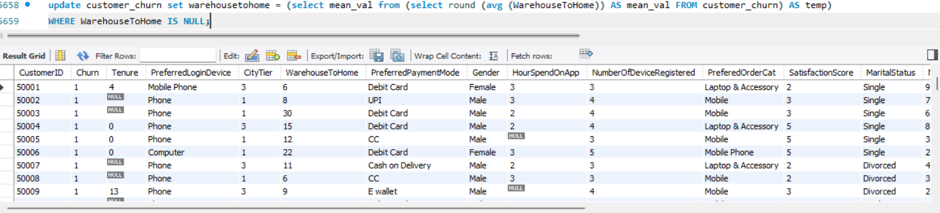
Impute mean for HourSpendOnApp
update customer_churn set HourSpendOnApp= (select mean_val from (select round (avg (HourSpendOnApp)) AS mean_val FROM customer_churn) AS temp)
WHERE HourSpendOnApp IS NULL;
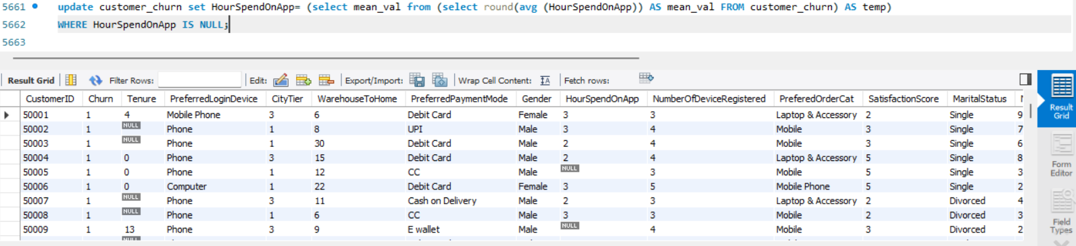
Impute mean for OrderAmountHikeFromlastYear
update customer_churn set OrderAmountHikeFromlastYear = (select mean_val from (select round(avg (OrderAmountHikeFromlastYear)) AS mean_val FROM customer_churn) AS temp)
WHERE OrderAmountHikeFromlastYear IS NULL;
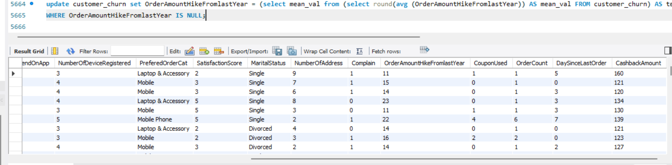
Impute mean for DaySinceLastOrder
update customer_churn set DaySinceLastOrder = (select mean_val from (select round(avg (DaySinceLastOrder)) AS mean_val FROM customer_churn) AS temp)
WHERE DaySinceLastOrder IS NULL;
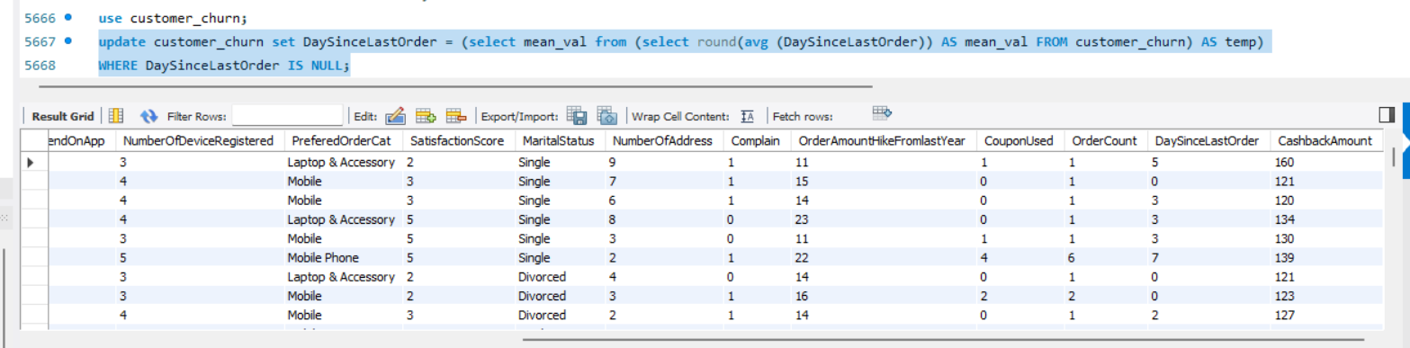

➢ Impute mode for the following columns: Tenure, CouponUsed, OrderCount.
- 1. Impute mode for Tenure
UPDATE customer_churn SET tenure = (
SELECT mode_val FROM (
SELECT tenure AS mode_val
FROM customer_churn
WHERE tenure IS NOT NULL
GROUP BY tenure
ORDER BY COUNT(*) DESC
LIMIT 1
) AS temp
)
WHERE tenure IS NULL;
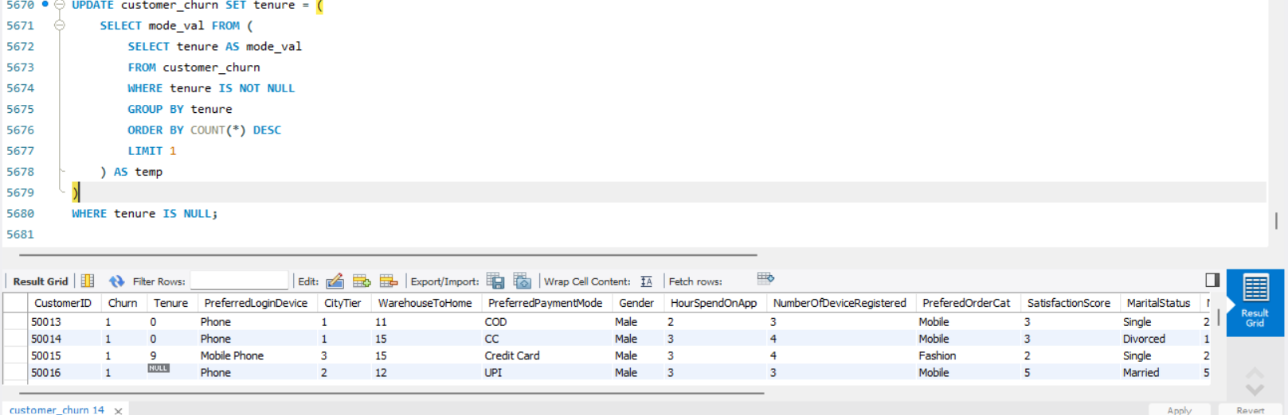
2. Impute mode for CouponUsed
use customer_churn;
UPDATE customer_churn SET CouponUsed = (
SELECT mode_val FROM (
SELECT CouponUsed AS mode_val
FROM customer_churn
WHERE CouponUsed IS NOT NULL
GROUP BY CouponUsed
ORDER BY COUNT(*) DESC
LIMIT 1
) AS temp
)
WHERE CouponUsed IS NULL;
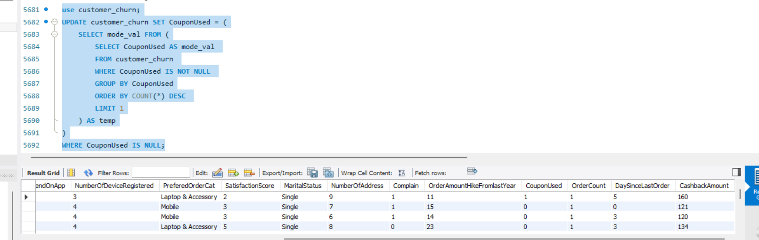
3. Impute mode for OrderCount
UPDATE customer_churn SET OrderCount = (
SELECT mode_val FROM (
SELECT OrderCount AS mode_val
FROM customer_churn
WHERE OrderCount IS NOT NULL
GROUP BY OrderCount
ORDER BY COUNT(*) DESC
LIMIT 1
) AS temp
)
WHERE OrderCount IS NULL;
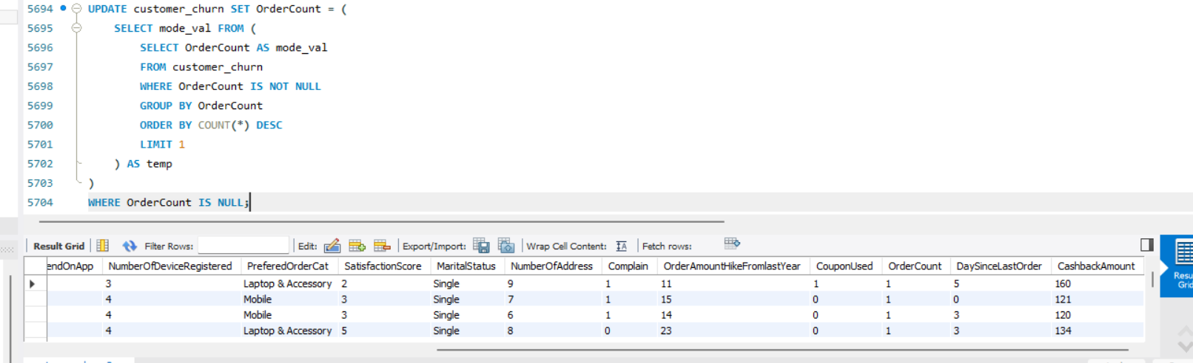
➢ Handle outliers in the 'WarehouseToHome' column by deleting rows where the values are greater than 100
SQL: DELETE FROM customer_churn
WHERE WarehouseToHome > 100;

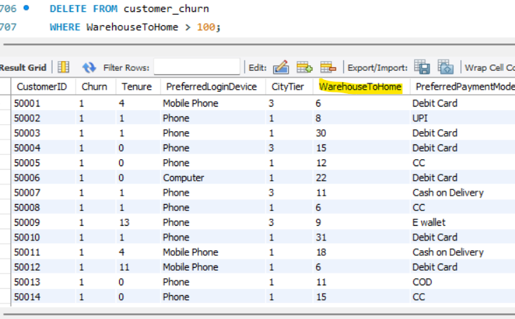
Dealing with Inconsistencies:
➢ Replace occurrences of “Phone” in the 'PreferredLoginDevice' column and “Mobile” in the 'PreferedOrderCat' column with “Mobile Phone” to ensure uniformity.
Replace "Phone" with "Mobile Phone" in PreferredLoginDevice

- SQL: UPDATE customer_churn SET PreferredLoginDevice = 'Mobile Phone' WHERE PreferredLoginDevice = 'Phone'
Replace "Mobile" with "Mobile Phone" in PreferedOrderCat

- UPDATE customer_churn SET PreferedOrderCat = 'Mobile Phone' WHERE PreferedOrderCat = 'Mobile';

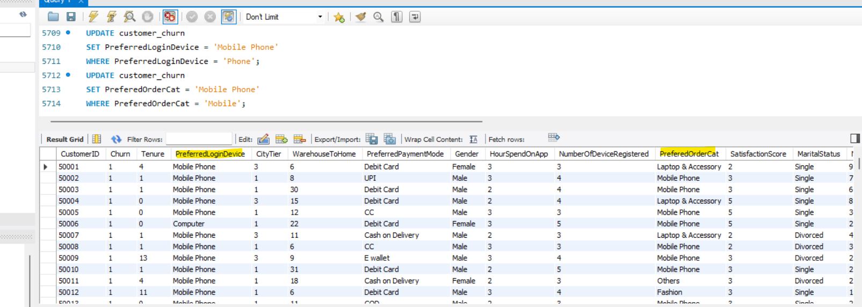

➢ Standardize payment mode values: Replace "COD" with "Cash on Delivery" and "CC" with "Credit Card" in the PreferredPaymentMode column
SQL:
Replace "COD" with "Cash on Delivery
- UPDATE customer_churn SET PreferredPaymentMode = 'Cash on Delivery' WHERE PreferredPaymentMode = 'COD';
Replace "CC" with "Credit Card
UPDATE customer_churn SET PreferredPaymentMode = 'Credit Card' WHERE PreferredPaymentMode = 'CC';

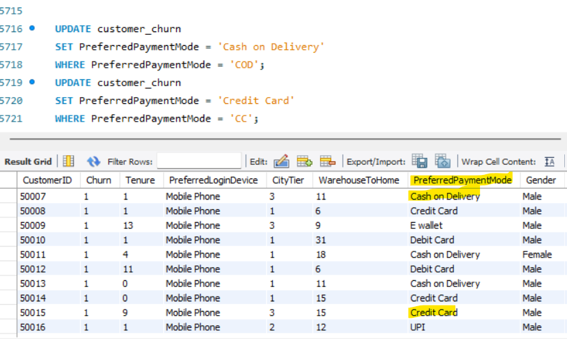

Data Transformation:
Column Renaming:
➢ Rename the column "PreferedOrderCat" to "PreferredOrderCat"
SQL:
ALTER TABLE customer_churn
RENAME COLUMN PreferedOrderCat TO PreferredOrderCat;
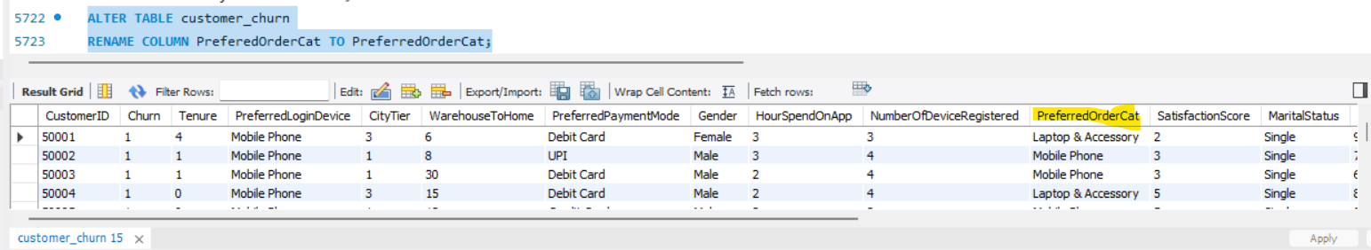
➢ Rename the column "HourSpendOnApp" to "HoursSpentOnApp".
SQL:
ALTER TABLE customer_churn RENAME COLUMN HourSpendOnApp TO HoursSpentOnApp;
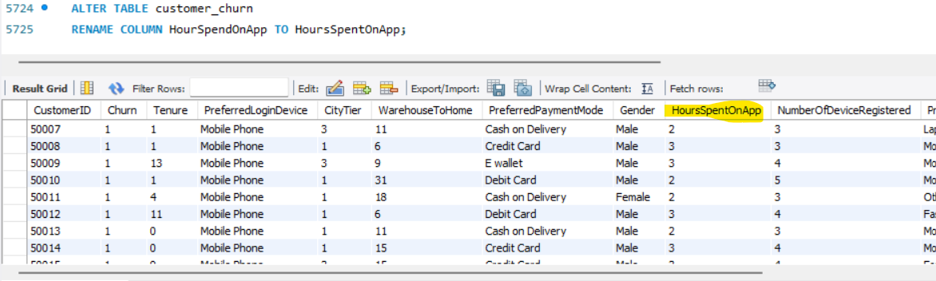

Creating New Columns:
➢ Create a new column named ‘ComplaintReceived’ with values "Yes" if the corresponding value in the ‘Complain’ is 1, and "No" otherwise.
Step 1:
ALTER TABLE customer_churn ADD COLUMN ComplaintReceived VARCHAR(5);
Step 2 :
UPDATE customer_churn SET ComplaintReceived = CASE WHEN Complain = 1 THEN 'Yes' ELSE 'No' END;

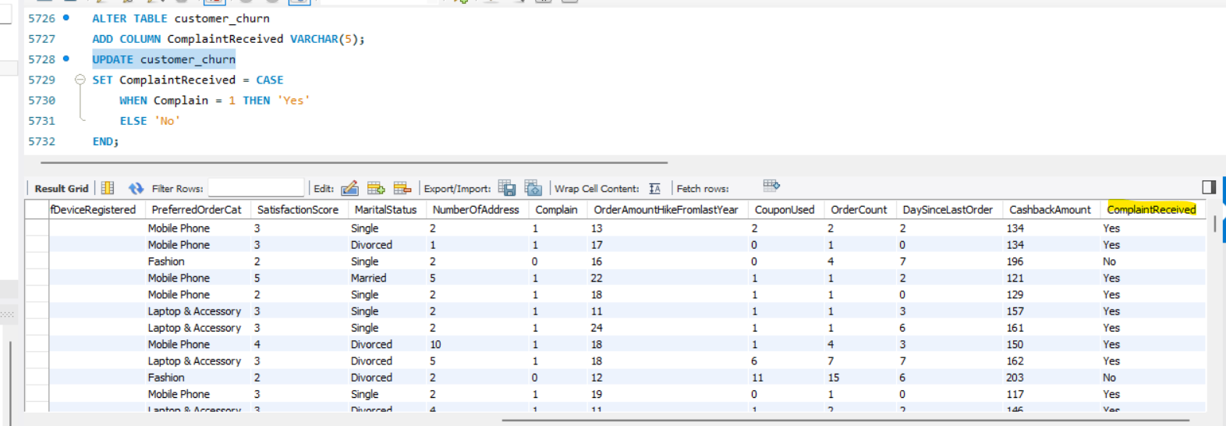
➢ Create a new column named 'ChurnStatus'. Set its value to “Churned” if the corresponding value in the 'Churn' column is 1, else assign “Active”.

Step 1 adding new column:
ALTER TABLE customer_churn ADD COLUMN ChurnStatus VARCHAR(10);
Step2: Update the new column based on the 'Churn' column
UPDATE customer_churn SET ChurnStatus = CASE WHEN Churn = 1 THEN 'Churned' ELSE 'Active' END;
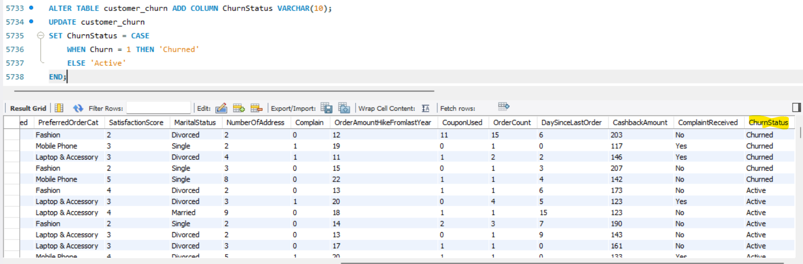

Column Dropping:
➢ Drop the columns "Churn" and "Complain" from the table.
SQL: ALTER TABLE customer_churn
DROP COLUMN Churn,
DROP COLUMN Complain;
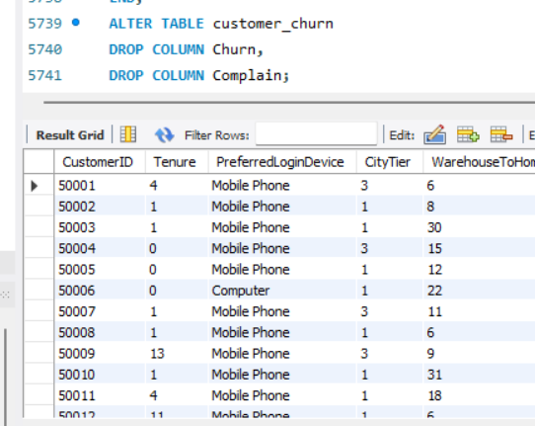
Data Exploration and Analysis:

➢ Retrieve the count of churned and active customers from the dataset
SQL:
SELECT ChurnStatus, COUNT(*) AS CustomerCount FROM customer_churn GROUP BY ChurnStatus;
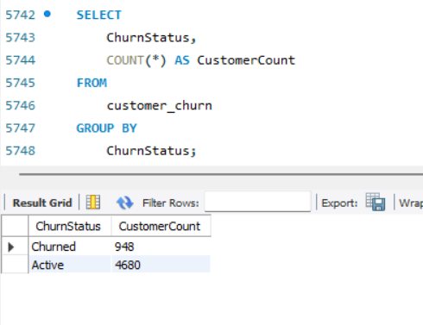
➢ Display the average tenure and total cashback amount of customers who churned.
SQL:
SELECT AVG(Tenure) AS AverageTenure, SUM(CashbackAmount) AS TotalCashback FROM customer_churn WHERE ChurnStatus = 'Churned';

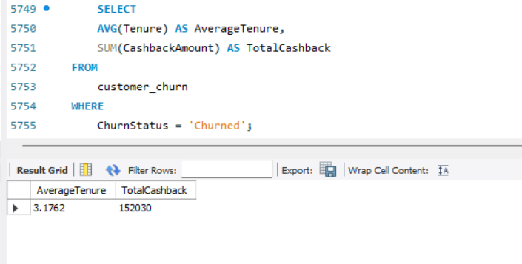

➢ Determine the percentage of churned customers who complained.
SQL:
SELECT (COUNT(CASE WHEN ComplaintReceived = 'Yes' THEN 1 END) / COUNT(*)) * 100 AS PercentageComplained FROM customer_churn WHERE ChurnStatus = 'Churned';

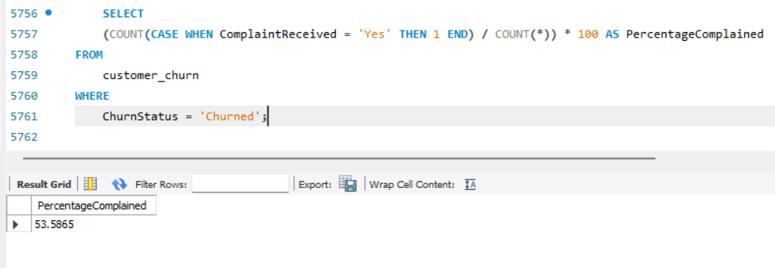
➢ Identify the city tier with the highest number of churned customers whose preferred order category is Laptop & Accessory.
SQL:
SELECT CityTier, COUNT(*) AS ChurnedCount FROM customer_churn WHERE ChurnStatus = 'Churned' AND PreferredOrderCat = 'Laptop & Accessory' GROUP BY CityTier ORDER BY ChurnedCount DESC LIMIT 1;
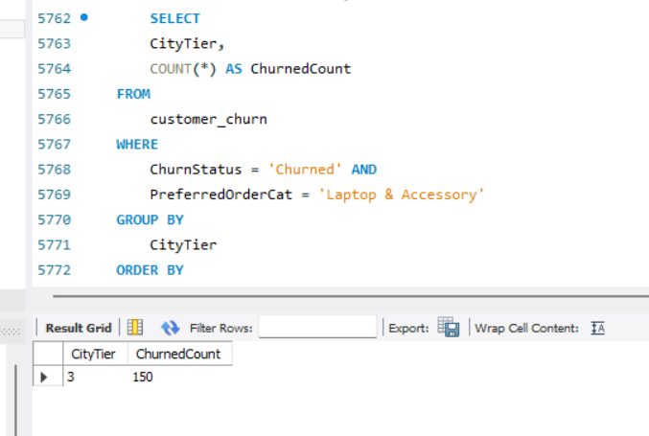
➢ Identify the most preferred payment mode among active customers.
SQL:
SELECT PreferredPaymentMode, COUNT(*) AS PreferenceCount FROM customer_churn WHERE ChurnStatus = 'Active' GROUP BY PreferredPaymentMode ORDER BY PreferenceCount DESC LIMIT 1;
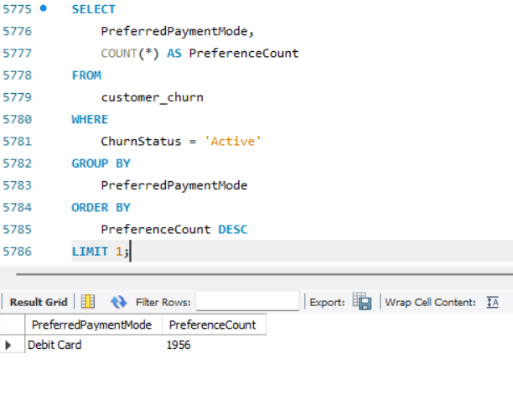
➢ Calculate the total order amount hike from last year for customers who are single and prefer mobile phones for ordering.
SQL:
SELECT SUM(OrderAmountHikeFromlastYear) AS TotalOrderAmountHike FROM customer_churn WHERE MaritalStatus = 'Single' AND PreferredOrderCat = 'Mobile Phone';

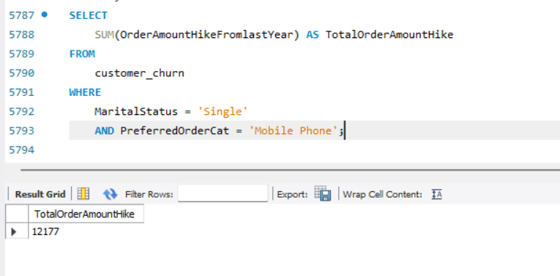
➢ Find the average number of devices registered among customers who used UPI as their preferred payment mode.
SQL:
SELECT AVG(NumberOfDeviceRegistered) AS AverageDevicesFROM customer_churn WHERE PreferredPaymentMode = 'UPI';
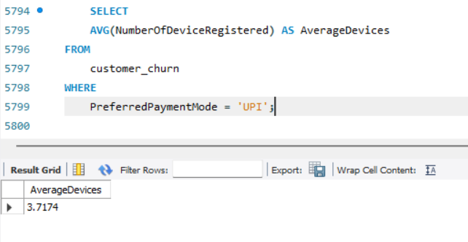
➢ Determine the city tier with the highest number of customers.
SQL:
SELECT CityTier, COUNT(*) AS CustomerCount FROM customer_churn GROUP BY CityTier ORDER BY CustomerCount DESC LIMIT 1;

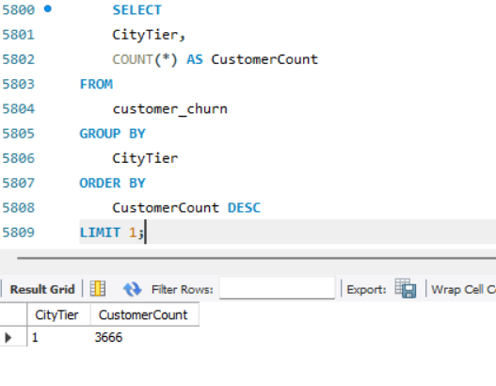
➢ Identify the gender that utilized the highest number of coupons.
SQL:
SELECT
Gender,
SUM(CouponUsed) AS TotalCoupons
FROM
customer_churn
GROUP BY
Gender
ORDER BY
TotalCoupons DESC
LIMIT 1;
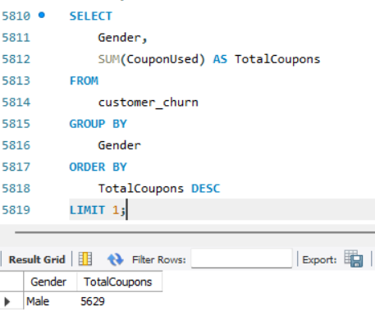
➢ List the number of customers and the maximum hours spent on the app in each preferred order category
SQL:
SELECT PreferredOrderCat, COUNT(*) AS NumberOfCustomers, MAX(HoursSpentOnApp) AS MaxHoursSpent FROM customer_churn GROUP BY PreferredOrderCat;
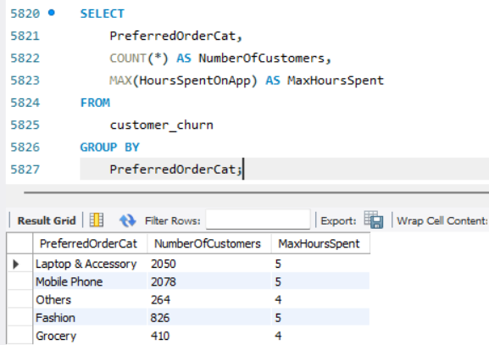

➢ Calculate the total order count for customers who prefer using credit cards and have the maximum satisfaction score.
SQL:
SELECT SUM(OrderCount) AS TotalOrders FROM customer_churn WHERE PreferredPaymentMode = 'Credit Card' AND SatisfactionScore = (SELECT MAX(SatisfactionScore) FROM customer_churn);
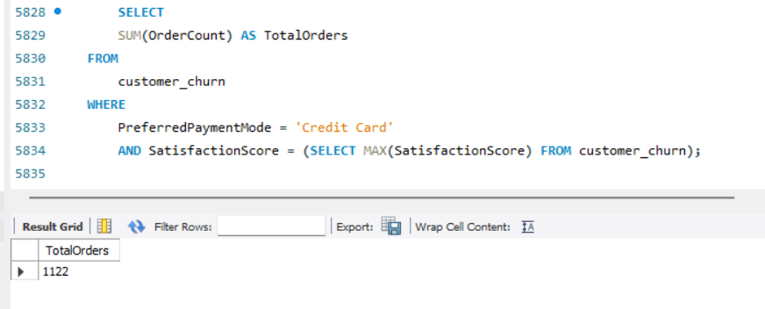
➢ What is the average satisfaction score of customers who have complained?
SQL:
SELECT AVG(SatisfactionScore) AS AverageSatisfactionScore FROM customer_churn WHERE ComplaintReceived = 'Yes';
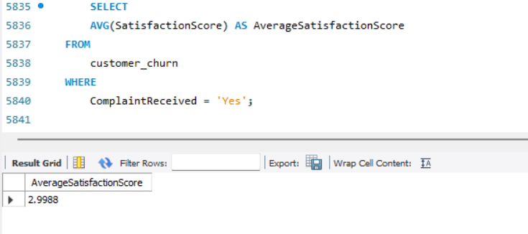
➢ List the preferred order category among customers who used more than 5 coupons.
SQL:
SELECT PreferredOrderCat, COUNT(*) AS CustomerCount FROM customer_churn WHERE CouponUsed > 5 GROUP BY PreferredOrderCat ORDER BY CustomerCount DESC;

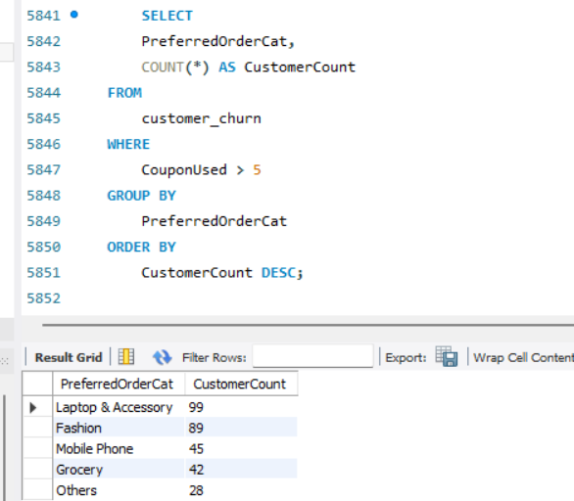

➢ List the top 3 preferred order categories with the highest average cashback amount.
SQL:
SELECT PreferredOrderCat, AVG(CashbackAmount) AS AverageCashback FROM customer_churn GROUP BY PreferredOrderCat ORDER BY AverageCashback DESC LIMIT 3;

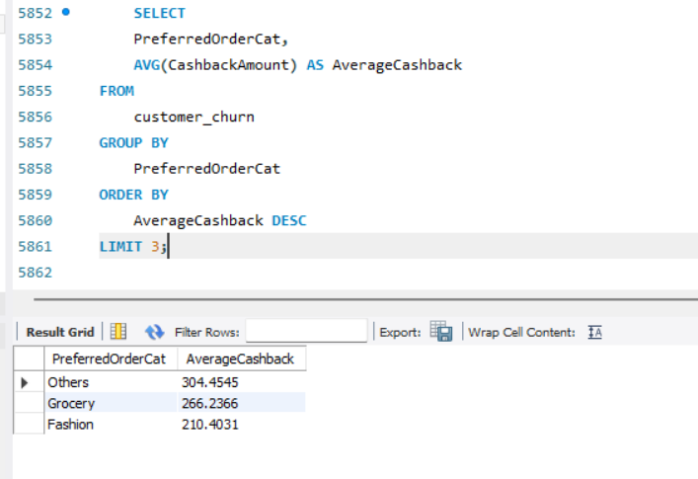
➢ Find the preferred payment modes of customers whose average tenure is 10 months and have placed more than 500 orders.
SQL:
SELECT PreferredPaymentMode FROM customer_churn GROUP BY PreferredPaymentMode HAVING AVG(Tenure) = 10 AND SUM(OrderCount) > 500;
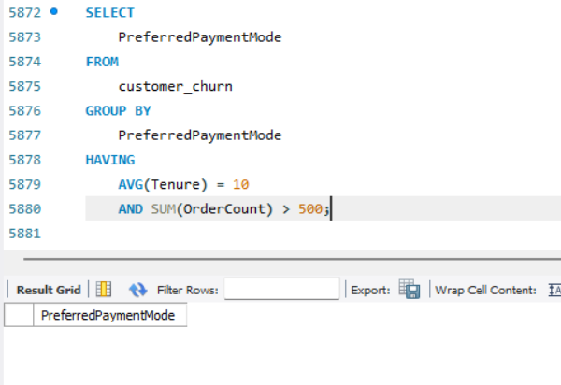
➢ Categorize customers based on their distance from the warehouse to home such as 'Very Close Distance' for distances <=5km, 'Close Distance' for <=10km, 'Moderate Distance' for <=15km, and 'Far Distance' for >15km. Then, display the churn status breakdown for each distance category.
SQL:
SELECT CASE WHEN WarehouseToHome <= 5 THEN 'Very Close Distance' WHEN WarehouseToHome <= 10 THEN 'Close Distance' WHEN WarehouseToHome <= 15 THEN 'Moderate Distance' ELSE 'Far Distance' END AS DistanceCategory, ChurnStatus, COUNT(*) AS CustomerCount FROM customer_churn GROUP BY DistanceCategory, ChurnStatus ORDER BY DistanceCategory, ChurnStatus;
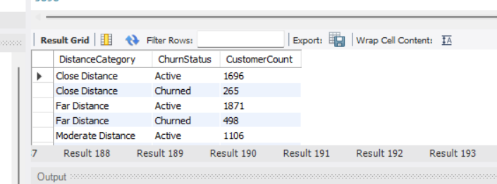
➢ List the customer’s order details who are married, live in City Tier-1, and their order counts are more than the average number of orders placed by all customers.
SQL:
SELECT CustomerID, OrderCount FROM customer_churn WHERE MaritalStatus = 'Married' AND CityTier = 1 AND OrderCount > (SELECT AVG(OrderCount) FROM customer_churn);
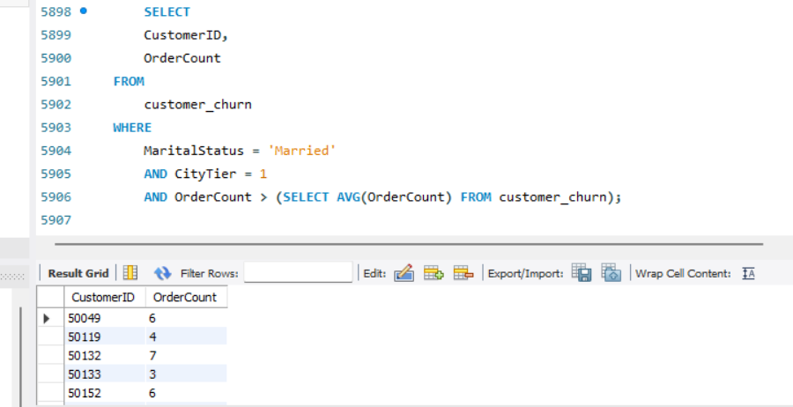
➢ a) Create a ‘customer_returns’ table in the ‘ecomm’ database and insert the following data: ReturnID CustomerID ReturnDate RefundAmount 1001 50022 2023-01-01 2130 1002 50316 2023-01-23 2000 1003 51099 2023-02-14 2290 1004 52321 2023-03-08 2510 1005 52928 2023-03-20 3000 1006 53749 2023-04-17 1740 1007 54206 2023-04-21 3250 1008 54838 2023-04-30 1990
b) Display the return details along with the customer details of those who have churned and have made complaints.
SQL:
- Create the customer_returns table and insert data
SQL:
USE ecomm;
CREATE TABLE customer_returns ( ReturnID INT PRIMARY KEY, CustomerID INT, ReturnDate DATE, RefundAmount INT ); INSERT INTO customer_returns (ReturnID, CustomerID, ReturnDate, RefundAmount) VALUES (1001, 50022, '2023-01-01', 2130), (1002, 50316, '2023-01-23', 2000), (1003, 51099, '2023-02-14', 2290), (1004, 52321, '2023-03-08', 2510), (1005, 52928, '2023-03-20', 3000), (1006, 53749, '2023-04-17', 1740), (1007, 54206, '2023-04-21', 3250), (1008, 54838, '2023-04-30', 1990);
- Display the return details along with the customer details of those who have churned and have made complaints

SQL:
SELECT cr.*, cc.* FROM customer_returns cr JOIN customer_churn cc ON cr.CustomerID = cc.CustomerID WHERE cc.ChurnStatus = 'Churned' AND cc.ComplaintReceived = 'Yes';

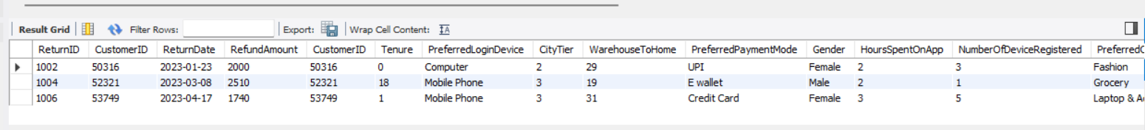

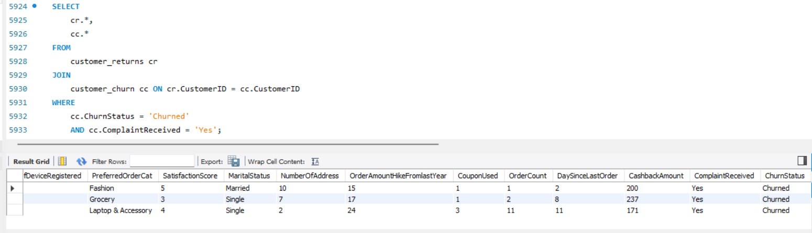

Conclusion
This project successfully investigated the dynamics of customer attrition within an e-commerce environment using historical transactional data and MySQL. By systematically cleaning the dataset—handling missing values, removing extreme outliers, and standardizing inconsistent categorical values, we have established a robust and reliable foundation for analysis.
Through comprehensive exploratory data analysis (EDA), we extracted critical insights into customer behaviour and the underlying drivers of churn. The SQL queries formulated in this project allowed to:
- Identify High-Risk Segments: Pinpoint specific demographics, city tiers, and marital statuses that exhibit a higher propensity to churn.
- Analyze Behavioral Patterns: Understand how factors like preferred payment modes, warehouse-to-home distance, app usage, and order categories correlate with customer retention.
- Evaluate Customer Satisfaction: Assess the direct impact of complaints, satisfaction scores, and cashback incentives on a customer's decision to stay or leave the platform.

Thank you

